Volunteer Handbook

Our Organisation & Where You Fit

Welcome to CVS!

Dear __________
Thank you for choosing to volunteer with us.
We at CVS seek to provide a positive environment for our staff, members, and dedicated volunteers. We hope you enjoy working with us.
Who are we?
The Community and Voluntary Services Cheshire East (CVSCE) was formed in January 2010, creating one organisation that supports the Voluntary and Community sector across Cheshire East.
We are a registered charity and a member of the National Association for Voluntary and Community Action and work closely with NAVCA members both locally and nationally.
We support lots of community groups—helping those that are starting up as well as long established organisations. We are an independent organisation supporting the development of a vibrant, effective, and influential voluntary and community sector across Cheshire East.
We also work in partnership with other organisations—from community groups to statutory bodies. We also support individuals who wish to become volunteers and those already involved in volunteering.
Our Vision
We aim to:
‘Build strong empowered communities that make a difference.’
By working in the voluntary, community and faith sector every day we continually strive to do this.
This is where you come in.
Volunteers
We are supported by a small but growing team of volunteers but are always looking to recruit more people. We cannot overstate the impact volunteers like you have.

Your Volunteering Plan

What would you like to get out of this experience?

What does volunteering mean to you?

Are you setting any goals for yourself as a volunteer – if so, how would you reach those goals?

What kind of volunteering activities do you enjoy?

Here is a table with a list of various volunteering roles. To figure out what you like, number them 1-5 in order of preference (5 being, ‘really don’t fancy that’ and 1 being ‘sign me up!’)

Role Description | Your Rating
IT Volunteer
Administrative Volunteer
Events Volunteer
Comms and Social Media
Design and Presentation

Joining Our Team

Throughout your volunteering journey, you will be supported by members of our team.

Our team consists of:

- Trustee Board
CVS Cheshire East has a Trustee Board who are volunteers and are accountable for the work and strategic development of the organisation. The Trustees meet on a regular basis and members are elected at the Annual General Meeting.

- The Management Team
Our dedicated management team: Kathryn Sullivan & Samantha James.

- Staff Team
We have 12 members of staff (full and part time). At the moment, we operate across Cheshire East but are based in Ashton House in Gatefield Street, Crewe.

Meet our lovely team:

Aoife Middlemass Helen Roger Alex Major

Dan Carroll Graham Brown Laura Shambrook

Tim Stubbs Sandra Griffiths Eve Naden

Here is an organisational chart to better illustrate our team:

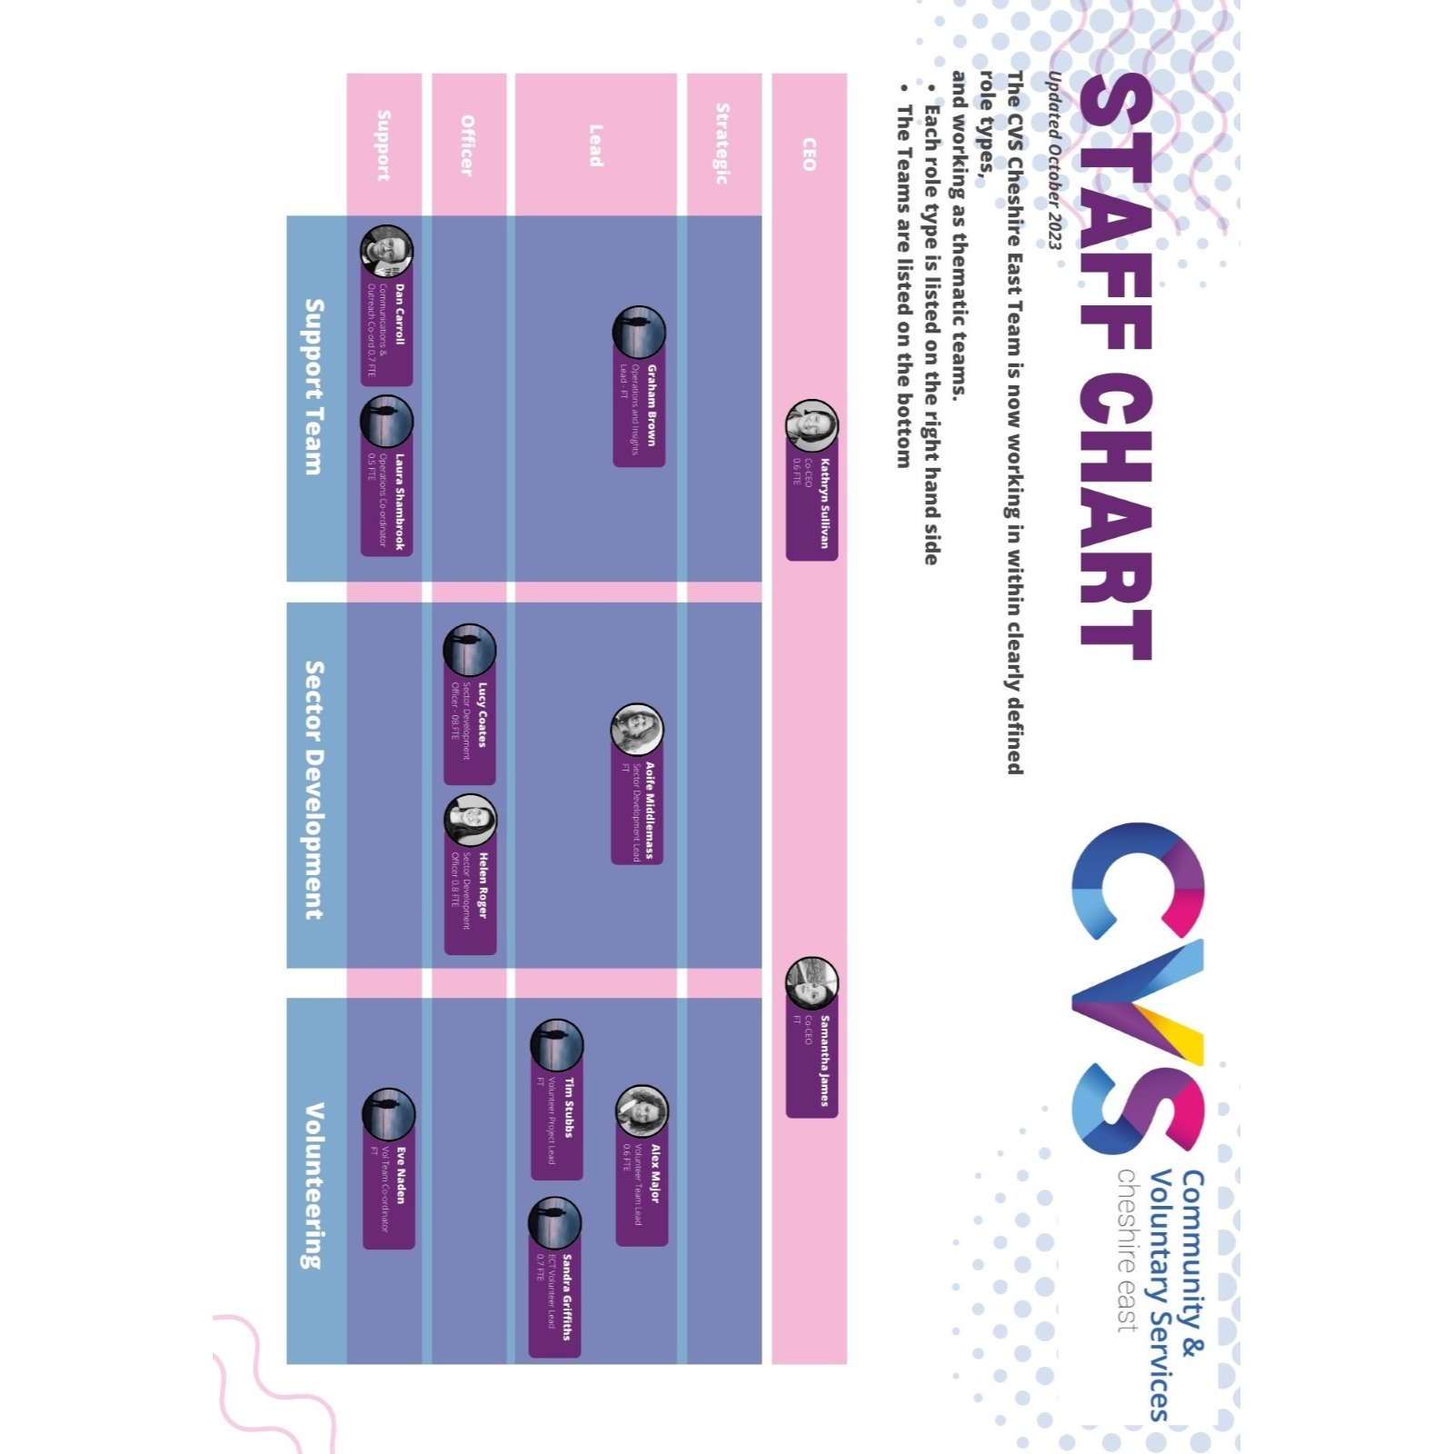

Organisational Quality Standards
Trusted Charity Mark

The Trusted Charity mark (formerly Pquasso) is a quality mark designed specifically for the voluntary and community sector. Since it was introduced in 1997, it has been used by thousands of organisations. It is the most used quality system in the UK for voluntary and community sector organisations.

11 quality areas are assessed:

- Governance
- Planning
- Leadership
- User-centred service
- Managing people
- Learning and development
- Managing money
- Manging resources
- External communications
- Working with others
- Assessing outcome and impact

CVS Cheshire East was awarded this quality standard in 2018.

How can you help us?

By upholding our values and behaviours in your role as a volunteer:

- Community-Orientated
- Care about your communities
- Invest in your communities and make a change
- Have a strong community team ethos

- Creativity
- Think differently
- Encourage new suggestions and alternative ideas
- Embrace change
- Willingness to have open discussions
- Take ownership of your ideas

- Nurturing
- To understand different people and perspectives
- Recognise and celebrate the potential in everyone
- Understand and foster different motivations
- Appreciate and respect each person’s uniqueness
- Listen to our members views and respond to help them flourish

How can we support you?

Support

As well as workbooks, personalised volunteering opportunities and training, we aim to to have a bi-monthly support session with all our volunteers. This is not a formal process but more of a casual discussion with your key person at CVSCE to help you feel supported in your volunteer role.

As a volunteer, you will also be supported with training and development. You are encouraged to attend relevant training courses and join us on our staff away days (but there is no pressure!)

Looking after yourself

Our volunteering sessions seek to provide advice and guidance on how to take care of yourself as a volunteer. It’s important that you don’t take on too much and only ‘give’ what you can. If you feel overwhelmed, our team will be there to support you.

Volunteer Expenses

We believe that no one should be at a financial disadvantage through volunteering their time on a freely chosen basis. Therefore, we’re committed to meet reasonable out-of-pocket expenses incurred by our volunteers, including:

- Travel between home and place of volunteering. This includes public transport or a mileage allowance. If traveling by public transport, please keep the ticket/recipet. If the volunteer is using his/her own transport, a record of all mileage must be kept.
- The mileage allowance paid will be concurrent with the general CVSCE staff mileage allowance. If a journey is in excess of 15 miles (round trip) volunteers are required to check the arrangements with the Finance & HR Manager beforehand. Volunteers claiming this allowance, must notify their motor insurance company and ensure their policy specifically includes “business use”.
- Car parking charges. The car park ticket must be retained, by way of receipt. If volunteering longer than five hours in any one period, a subsistence allowance to a maximum of £3.50, will be paid. Receipts for items purchased must be kept.
- Claims for expenses should be made on a CVSCE Volunteer Expenses Claim form and submitted monthly, they are paid retrospectively.

What kind of transport do you take? Tick all that apply below.

- Car
- Bus
- Train
- Walking

Reporting Concerns

At CVS, we are committed to an open dialogue between our staff and volunteers. If you have any concerns, you should first speak to your supervisor, the responsible Development Officer or the relevant manager who will try and resolve the matter informally. If the matter remains unresolved, reference will be made to the Problem Solving Procedure for volunteers, a copy of which is in the Volunteer’s information File. All complaints will be dealt with within 10 working days and treated in a confidential manner.

Endings & References

You can end your volunteering agreement with us at any time; this is not a job. You are not under contract, so don’t worry.

While we at CVSCE can also end the volunteering agreement, we aim to give at least 2 weeks’ notice, hoping that you will offer the same to us. Asking you to leave your role is a last resort. It might not be possible to keep a volunteer, for reasons nothing to do with the person’s performance but due to, for example, a project ending. It may be necessary to ask a volunteer to leave due to, for example, poor performance, misconduct, attendance irregularities, DBS issues or criminal convictions.

Every effort will be made to ensure that the reasons for ending an involvement are clarified, recorded, and shared with the volunteer. Where a specific volunteer role within CVSCE has proved not to be suitable for a particular person, the responsible Development Officer or the Membership Services Manager will assist them to explore other options. At the end of your time with us, we’d love to know about your views and experiences. These will be captured with our Exit Questionnaire, which aims to gather information on the following areas:

- Your “best bits” whilst volunteering with us
- Your views on the training and support that was offered or received
- Feedback on how you feel you performed, as well as responding to feedback from others
- Any improvements you would suggest to make the volunteering experience better.

If asked, we will supply a reference, based on your time with us, indicating the skills and knowledge acquired as well as personal qualities observed.

Thank you so much for your time getting through this booklet. Part 2 will be more focused on our policies and procedures to keep you safe and informed.

Welcome to Our Team!

POLICY DATED (insert date when approved by trustees/board): ____________________

SIGNED (Chair of the meeting): __________________________

REVIEW DATE: 2 years after date of policy

