Example

Fundraising Strategy

2017-2020

**Organisation aims:**

**Info to be inserted here**

**Introduction**

**Background of organisation**

**Strategic Aims**

To be completed

|  |  |
| --- | --- |
| Strategic Aim 1 | Objective 1 |
|  |  |
| Strategic Aim2 | Objective 2 |
|  |  |
| Strategic Aim 3 | Objective 3 |
|  |  |

**Current position (income)**

To be completed

|  |  |  |  |  |
| --- | --- | --- | --- | --- |
| Funding Source | Funding For? | Amount | Funding Expires | Further information |
|  |  |  |  |  |
|  |  |  |  |  |
|  |  |  |  |  |

**Funding Needs 2017 -2020**

*Insert needs here*

**Fundraising SWOT analysis**

|  |  |
| --- | --- |
| **Strengths** | **Weaknesses** |
| **Opportunities** | **Threats** |

**Areas for development**

*[Provide information about where your organisation would like to be in the future and what it would need in terms of resources to get there. Include information about how your organisation could diversify its income streams and avoid relying on funding from one source].* ***Consider the Income Spectrum (below).***

|  |
| --- |
|  |

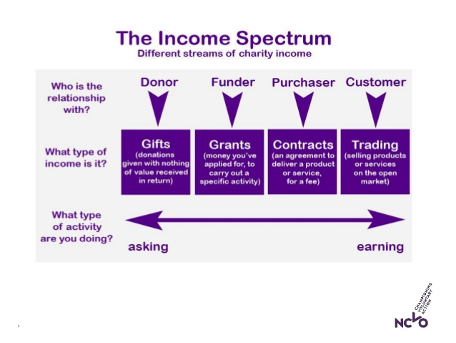

**Step 1: Screening**

Identify and list a variety of different potential funding sources including sources including both methods of ‘asking’ for funds (grants, donations) and methods of ‘earning’ income (trading, contracts].

*Include current income in this plan and any ideas are welcome.*

**Heritage – Building**

|  |  |  |  |  |
| --- | --- | --- | --- | --- |
| Funding Source | Method (asking or earning) | Amount | Deadline/ who | Other information |
|  |  |  |  |  |
|  |  |  |  |  |
|  |  |  |  |  |

**Ongoing core and running costs**

|  |  |  |  |  |
| --- | --- | --- | --- | --- |
| Funding Source | Method (asking or earning) | Amount | Deadline/ who | Other information |
|  |  |  |  |  |
|  |  |  |  |  |
|  |  |  |  |  |

**Project**

|  |  |  |  |  |
| --- | --- | --- | --- | --- |
| Funding Source | Method (asking or earning) | Amount | Deadline/ who | Other information |
|  |  |  |  |  |
|  |  |  |  |  |
|  |  |  |  |  |

**Others?**

|  |  |  |  |  |
| --- | --- | --- | --- | --- |
| Funding Source | Method (asking or earning) | Amount | Deadline/ who | Other information |
|  |  |  |  |  |
|  |  |  |  |  |
|  |  |  |  |  |

**Step 2: Short listing**

Include information about the appropriateness and probability of success of the funding sources identified in the screening process.

|  |  |  |  |  |
| --- | --- | --- | --- | --- |
| Funding Source | Probability of success | Risks | Benefit | Other information |
|  |  |  |  |  |
|  |  |  |  |  |
|  |  |  |  |  |

**Step 3: Actions and Timescales**

Include information about what funds will be sourced, what actions will be taken, by whom/ when.

|  |  |  |  |  |  |
| --- | --- | --- | --- | --- | --- |
| No. | Funding Source | Who responsible? | Resources Needed | Action required | Timescale |
|  |  |  |  |  |  |
|  |  |  |  |  |  |
|  |  |  |  |  |  |

**Step 4: Measuring progress**  
Include information about what systems will be put in place to monitor the progress of

your strategy.

|  |  |  |  |  |  |
| --- | --- | --- | --- | --- | --- |
| Date | Funding Source | Method of Reporting Progress | Action required | By Whom | When |
|  |  |  |  |  |  |
|  |  |  |  |  |  |
|  |  |  |  |  |  |

**Contingencies / exit strategy**

Include information about contingency plans if funding bids/ income generation plans fail for existing projects.

|  |  |  |  |
| --- | --- | --- | --- |
| Project | Funding Source | Alternative Funding Source | Exit Plan |
|  |  |  |  |
|  |  |  |  |
|  |  |  |  |