Developing a Theory of Change

Most charities and not-for-profit organisations exist to bring about change in some way. Change for individuals, for societies, or for the world at large. Bringing about those changes often involves working within complex systems and for long periods of time.

Theory of Change is an increasingly popular tool for organisations to describe how they believe that change happens, and to help focus their work on achieving their long-term goals.

There are many ways to display a Theory of change graphics.
Here are some examples;
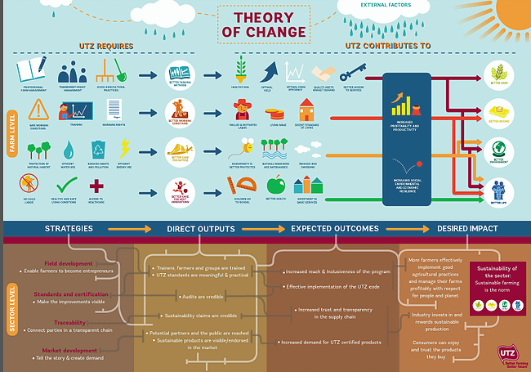

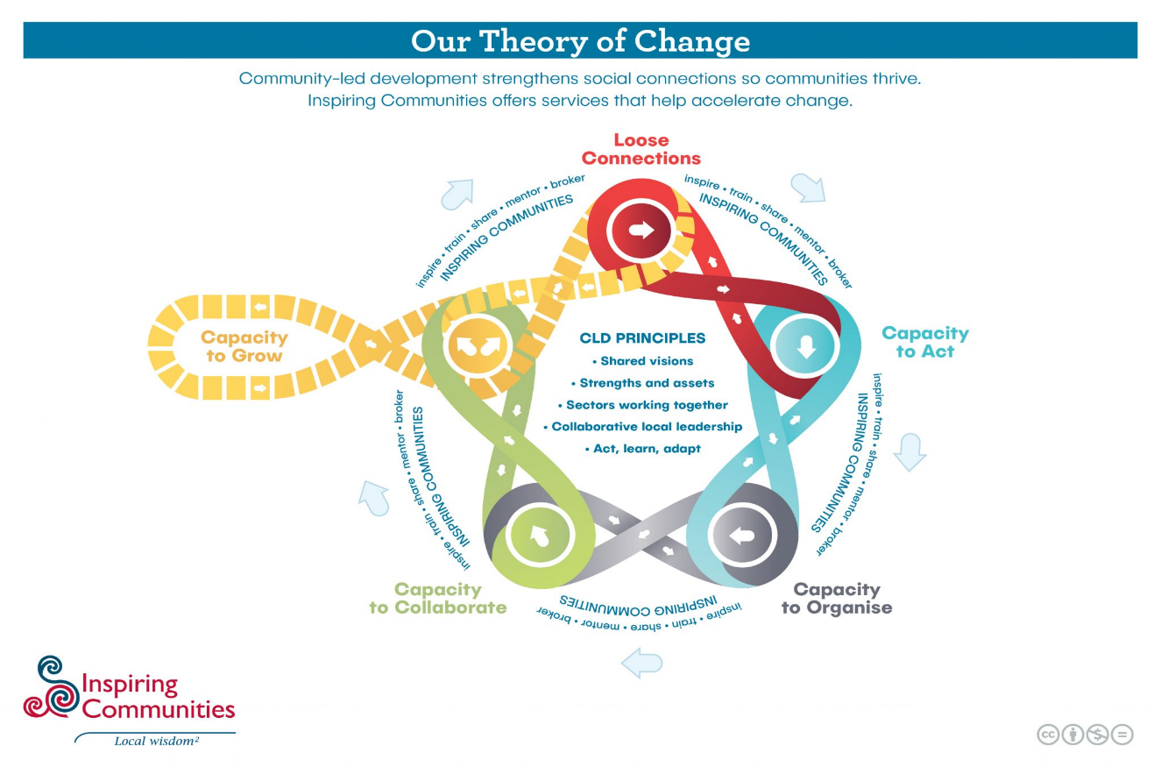
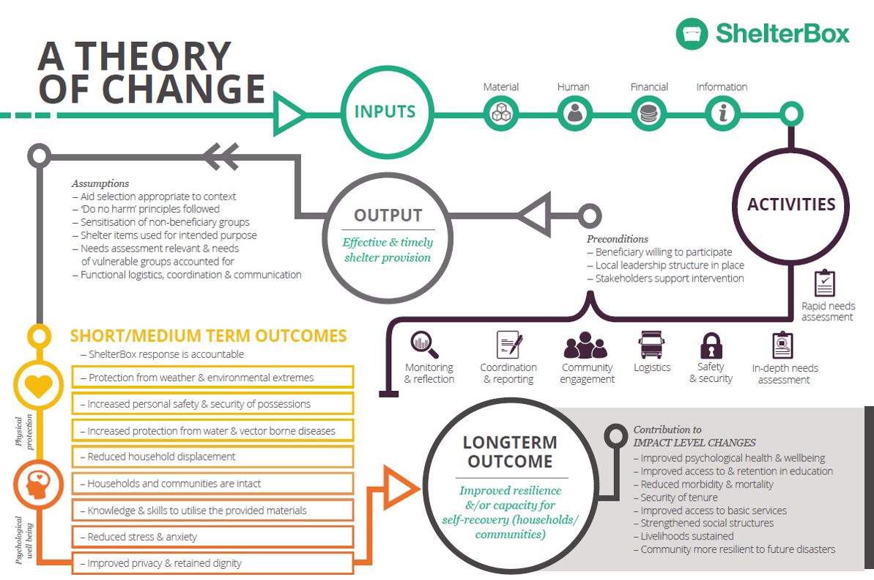

A projects or organisation’s Theory of Change describes how it believes it makes a difference. It should clearly link inputs / activities to immediate outcomes and to achieving the organisation’s overall long-term impacts. (It is usually expressed as a diagram with an accompanying narrative that explains the model.)

Why Develop a Theory of Change?
Organisations choose to develop a theory of change for a number of reasons;

When developing strategy
Theory of Change helps people focus on the organisation’s purpose and overall goal. They can use it as a way to identify what needs to happen for that goal to be reached, rather than starting from, and maybe getting too caught up in, current activities.

Defining their place in a sector
When considering a system or sector as a whole, the Theory of Change can help an individual organisation define its place in it. This can involve identifying where it can play a role that is different to other actors. It can help to identify other organisations to cooperate with. And it can highlight where there is a need to influence others to play a particular part.

For Measurement & Evaluation
A Theory of Change explicitly articulates the causal pathway that will lead to the end goal. This enables organisations to identify the key things that they have to measure. Where the change process takes place over an extended time frame, and so you will not be able to measure the end result for some time, knowing the contributing activities makes it easier to identify lead indicators that show whether or not you are making progress.

To ensure a shared understanding
Often, different stakeholders in an organisation have different understandings of how an organisation is trying to make a difference. They might not even agree on the difference the organisation is trying to make. The process of developing a Theory of Change involves discussion and decision about these issues. The final Theory of Change results in a clear articulation that can be shared and understood by all.

To communicate with funders
For some organisations, the initial reason for developing a Theory of Change is that a funder requires one. Whether or not its development is funder-driven, a Theory of Change can be a powerful way to show why an organisation is doing what it does, and the difference it will make. It can be a valuable complement to the traditional case for support when making approaches to funders and major donors.

