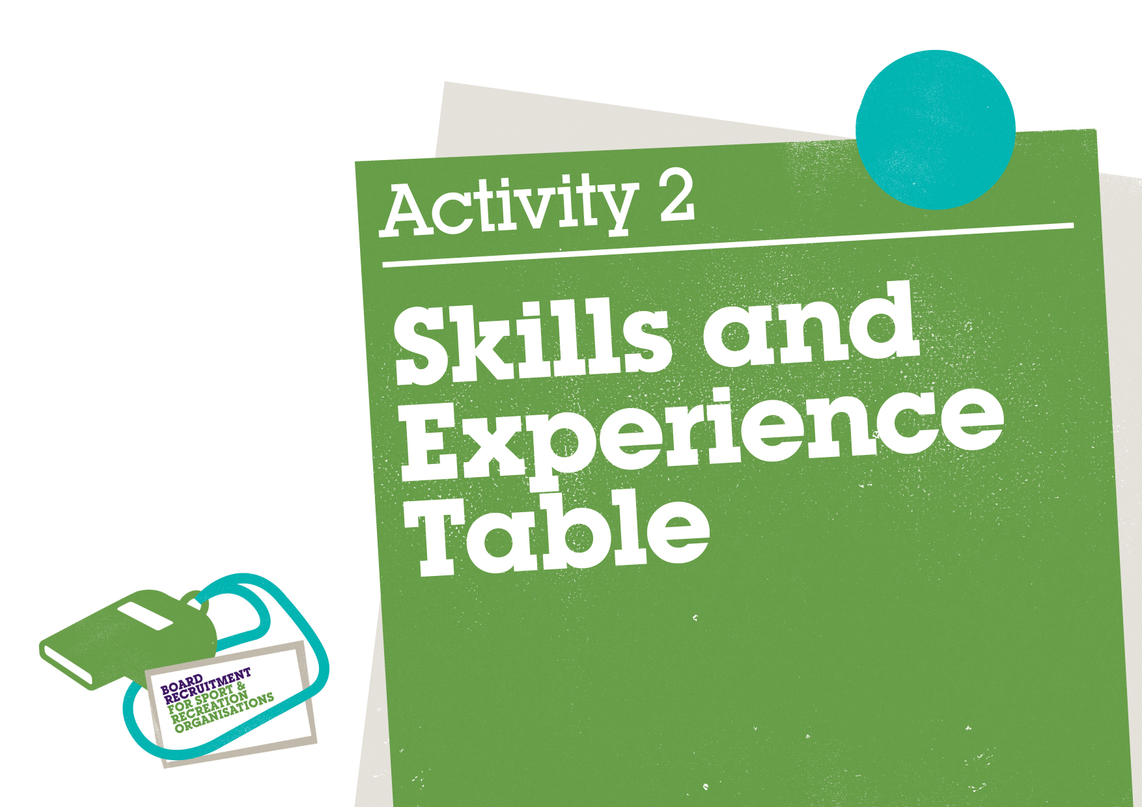
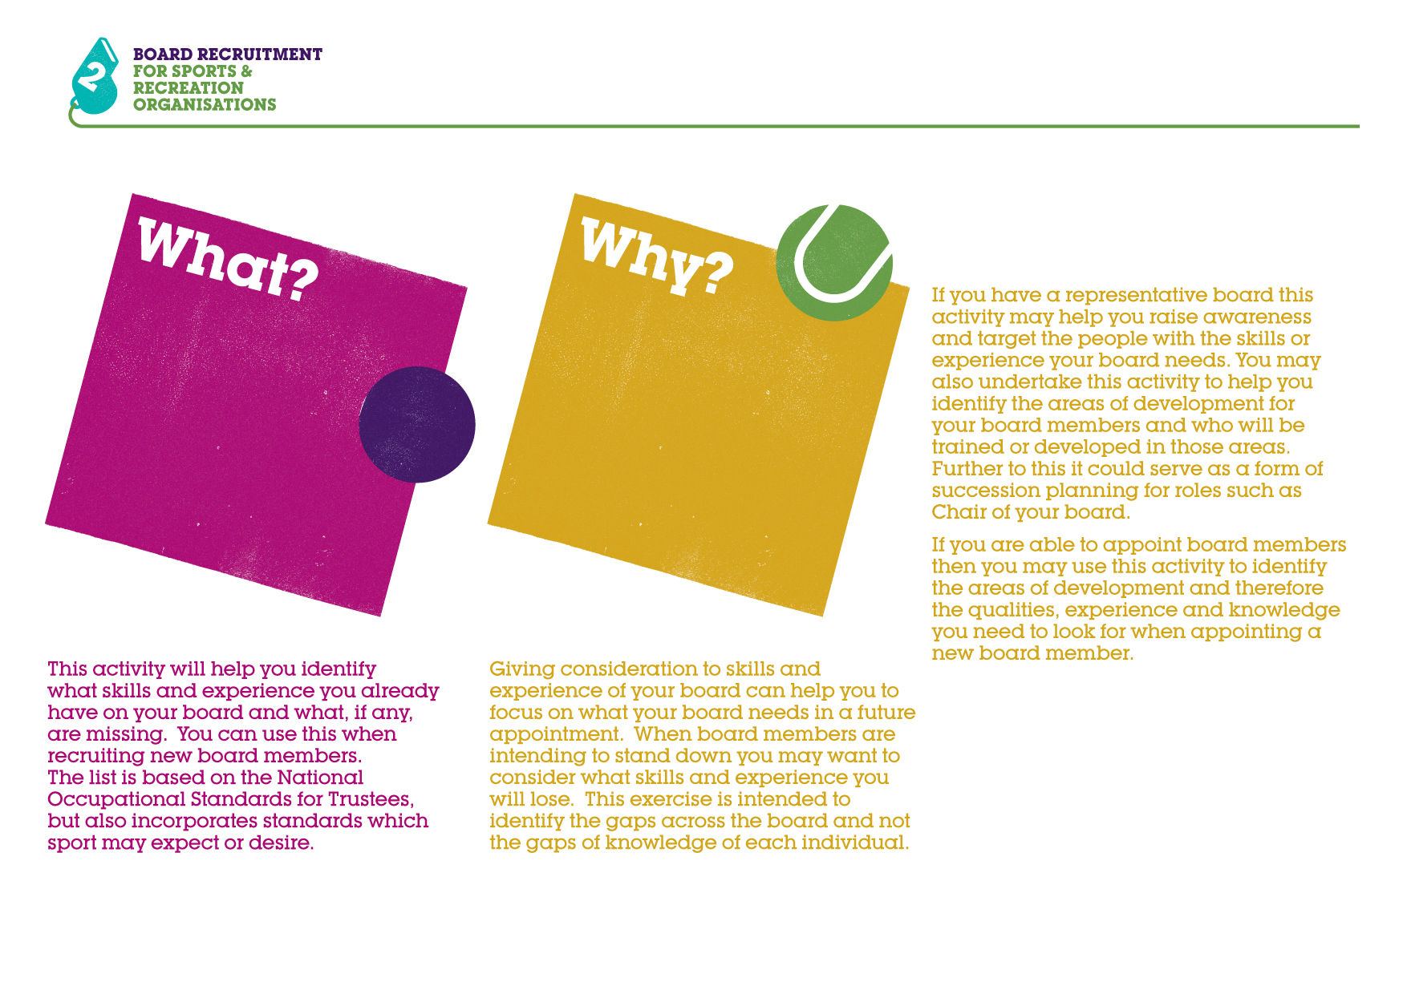

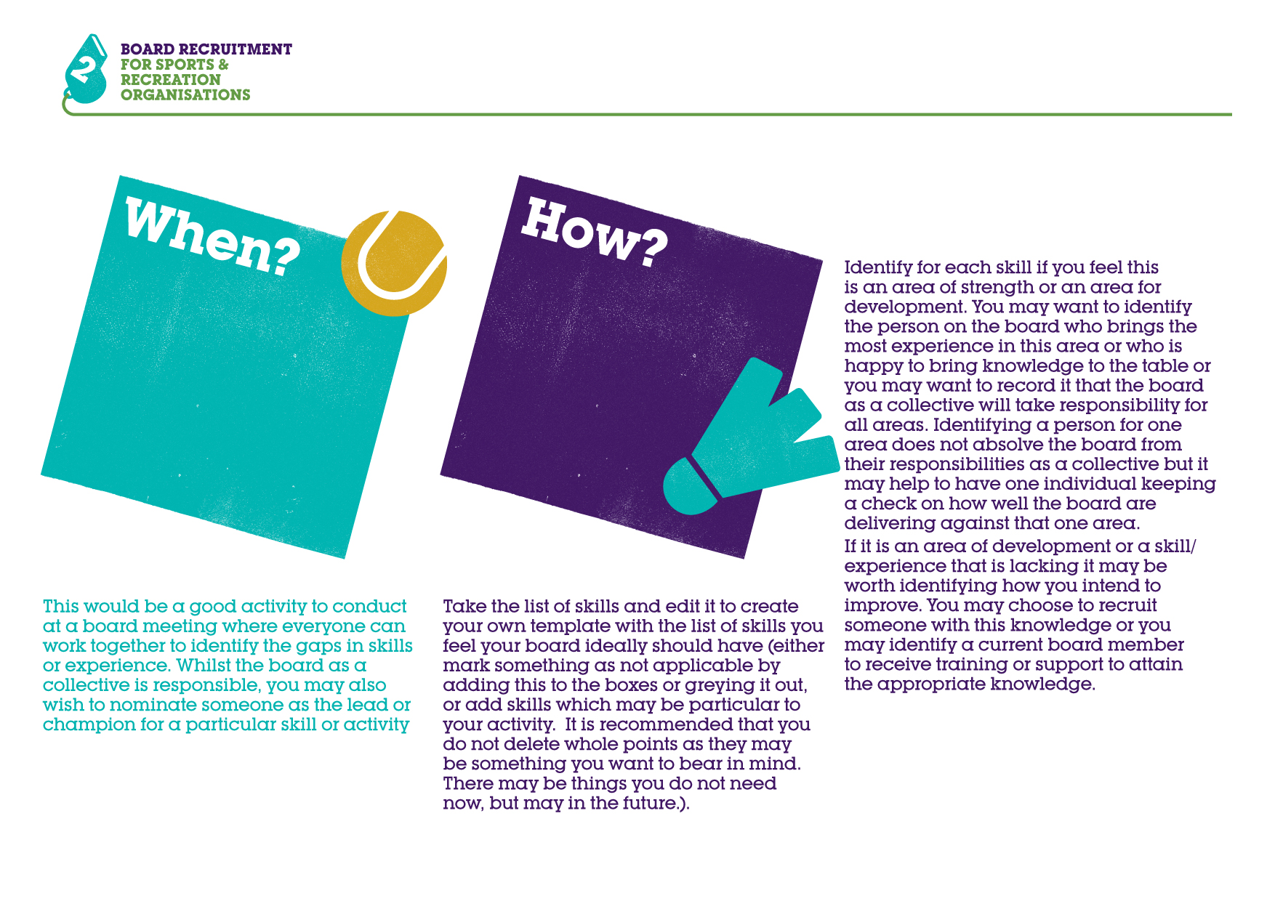
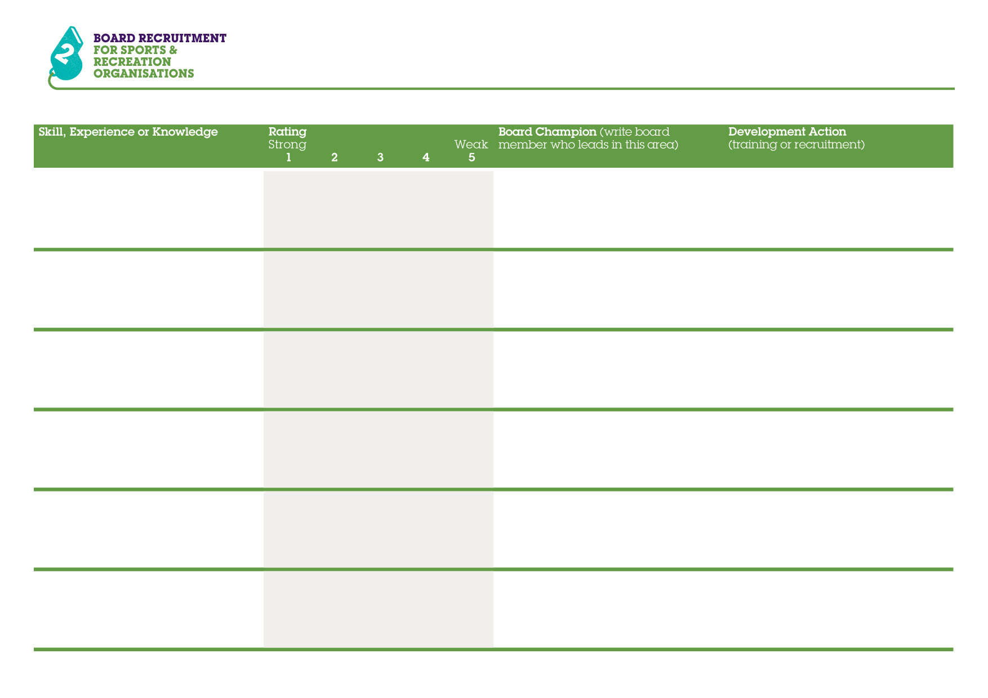
Administration
Business development
Campaigning
1 2 3 4 5

1 2 3 4 5

1 2 3 4 5

1 2 3 4 5

1 2 3 4 5

1 2 3 4 5

Change management
Conflict resolution
Consultancy

Customer care
Diversity and inclusion
Event management
1 2 3 4 5

1 2 3 4 5

1 2 3 4 5

1 2 3 4 5

1 2 3 4 5

1 2 3 4 5

Financial/Budget control
Fundraising
Strategic planning and management

Leadership
Governance
Knowledge of sport
and recreation sector
1 2 3 4 5

1 2 3 4 5

1 2 3 4 5

1 2 3 4 5

1 2 3 4 5

1 2 3 4 5

HR/Training
Information technology
Legal
Management
Marketing
Media/PR
1 2 3 4 5

1 2 3 4 5

1 2 3 4 5

1 2 3 4 5

1 2 3 4 5

1 2 3 4 5

Member relations
Networks and sector relationships
Public affairs
Policy implementation
Property management
Research
1 2 3 4 5

1 2 3 4 5

1 2 3 4 5

1 2 3 4 5

1 2 3 4 5

1 2 3 4 5

Sports development
Systems and processes
Understanding of sport structures

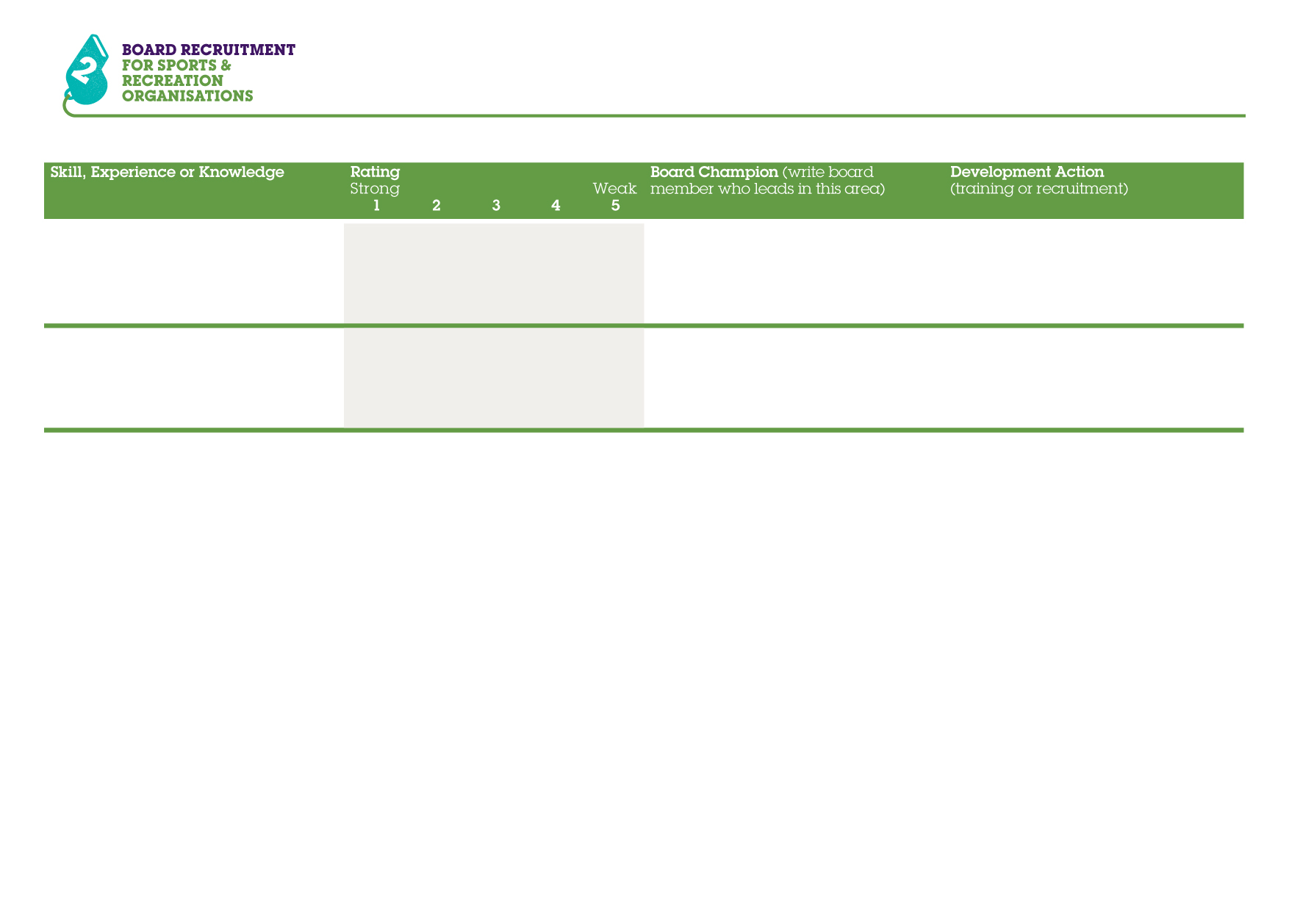
Understanding of wider
recreational activities/issues
Add skills specific to
your organisation
1 2 3 4 5

1 2 3 4 5

